CENG 3131: Lab for Telecom & networks – Lab 1 Transmission and Attenuation

*Goals: Model a transmission line using Multisim and observer the attenuation distortion.*

# Introduction

This lab introduces the circuit schematic simulation tool for engineering and science – MultiSim. The tasks in this lab are:

Transmission impairments are discussed in section 3.3 of your text book. Review the material on attenuation distortion. Note that Fig. 3.15 shows attenuation in dB, where a reference signal of 1000 Hz is used.

In this experiment you will model a transmission line in Multisim .You will record amplitude values of the signal at the end of the “transmission line” and observe how the attenuation is not only a function of distance but also a function of frequency.

Read through the entire lab and scan any supplied files before starting work. Note, before running a simulation, you should always have a general understanding of how your circuit works.

# TASK 1: Build the simulated transmission system

For this task you will learn how to use MultiSim to do simulation.

1. Open up Multisim.
2. Add a digital clock (sources) as a source transmitter, in the left part of the screen.

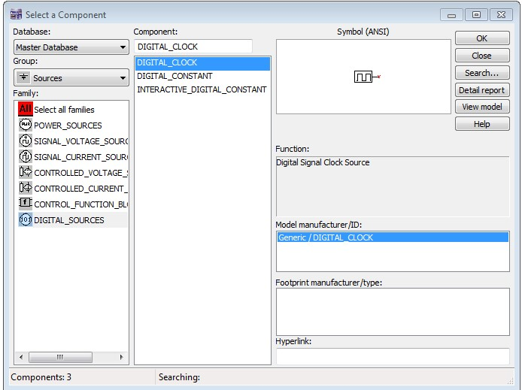

1. Add a digital ground.

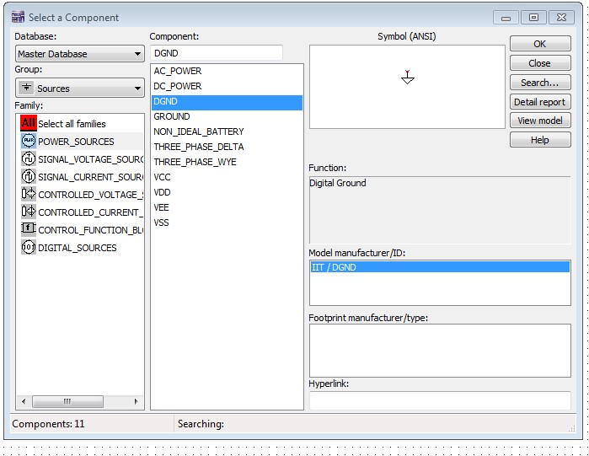

1. Add a lossy transmission line

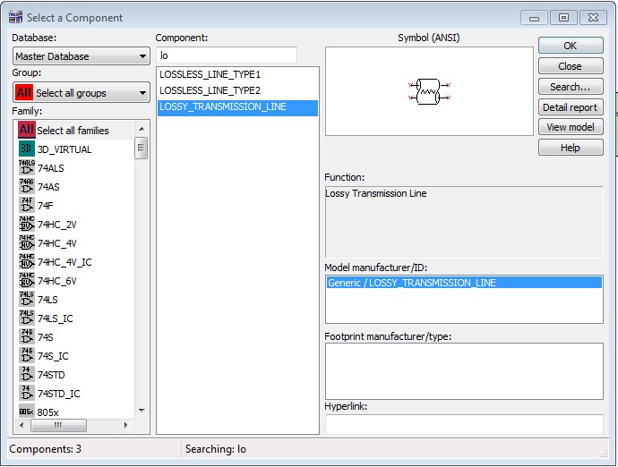

1. Connect the digital clock to the top wire of the transmission line on the left.
2. Connect the digital ground to the bottom left of the simulation.
3. Add a scope as the receiver/sink to the right side of the simulation.
4. Connect Channel A of the scope to the left side of the transmission line and Channel B to the right side; grounds should be connected to the bottom right hand side of the transmission line.

**Question:**

In your report, please include the schematic of the simulation.

# TASK 2: Investigate attenuation as a function of frequency

1. Set the transmission line parameters as follows:
   1. Length = 1 meter
   2. Resistance/unit = 1 ohm
   3. Inductance/unit = 0 henries
   4. Capacitance/unit = 1 micro farads (1 uF)
   5. Conductance/unit = 0 mhos
2. Set the Scope parameters as follows:
   1. Time Scale = 1 micro second/div to 1 ms/div
   2. Amplitude Scale = 5 volts/division (on Channel A and B)
3. Set the Digital Clock to 50% duty cycle; 0 delay.

**Question:**

1. Please give the figure of scope with all the parameters been set.
2. Fill out the following Table. Adjust the clock and scope as needed. (Channel B is the signal)

|  |  |  |  |
| --- | --- | --- | --- |
| Frequency (Digital Clock) | Output Peak Voltage | Smallest Output Voltage | Peak to Peak Voltage |
| 10 k hz | 9.996 V | 5.015 V | 4.981 V |
| 100 k hz | 9.982 V | 5.048 V | 4.934 V |
| 1000 k hz | 8.797 V | 6.712 V | 2.085 V |

Briefly discuss your observation and conclusion. What happens to the output as the frequency increases?

# TASK 3: Investigate attenuation as a function of distance

1. Return the scope to the values in task 2.2.
2. Set the digital clock as in task 2.3 and set the frequency to 100k Hz.
3. Set the transmission line parameters as in task 2.1.

**Question:**

* 1. Please give the figure of scope with all the parameters been set.
  2. Fill out the following Table. Adjust the transmission line and scope parameters as needed. (Channel B is the signal)

|  |  |  |  |
| --- | --- | --- | --- |
| Distance (meters) | Output Peak Voltage | Smallest Output Voltage | Peak to Peak Voltage |
| 1 meter | 9.982 V | 5.048 V | 4.934 V |
| 10 meters | 10 V | 9.976 V | 24.412 mV |
| 100 meters | 10 V | 10 V | 1.776 fV |

* 1. Briefly discuss your observation and conclusion. What happens to the output as the distance increases?

# Laboratory Report

In no later than 14 days from the starting time your lab section, provide the TA a hard copy of a lab report following the CENG 3131 Lab report Template given on the Black Board. You can write it down to the lab book or include your report in lab book. Each student will submit one lab report to the TA. Your report should have the reporting requirements needed for all tasks. **The TA will take off a significant number of points if your does not follow the lab template.**

# GRADING POLICY

1. Completion of Task 1 with results included in lab report (20%)

2. Completion of Task 2 with results included in lab report (35%)

1. Completion of Task 3 with results included in lab report (35%)
2. Completeness, quality, and correctness of the lab report (10%)